**System Architecture**

The architecture of encrypted search over ***private blockchain*** is illustrated in Fig. 1, which contains two main modules:

* **Client module:** porting plaintext datasets to encrypted blockchain storage and generating secure query;
* **Blockchain module:** providing encrypted data storage and privacy-assured keyword search on encrypted data;

Fig. 1 System architecture

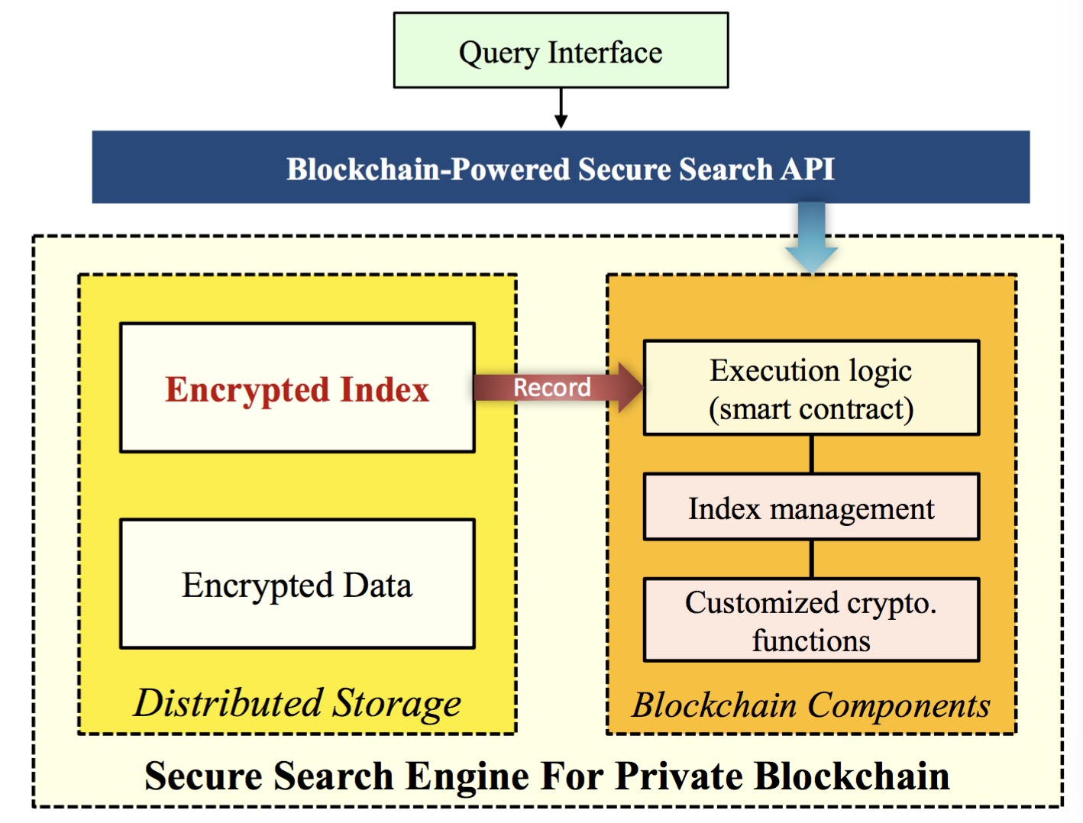

Fig. 2 Core algorithms

(for more clarifications, please refer to our documents)

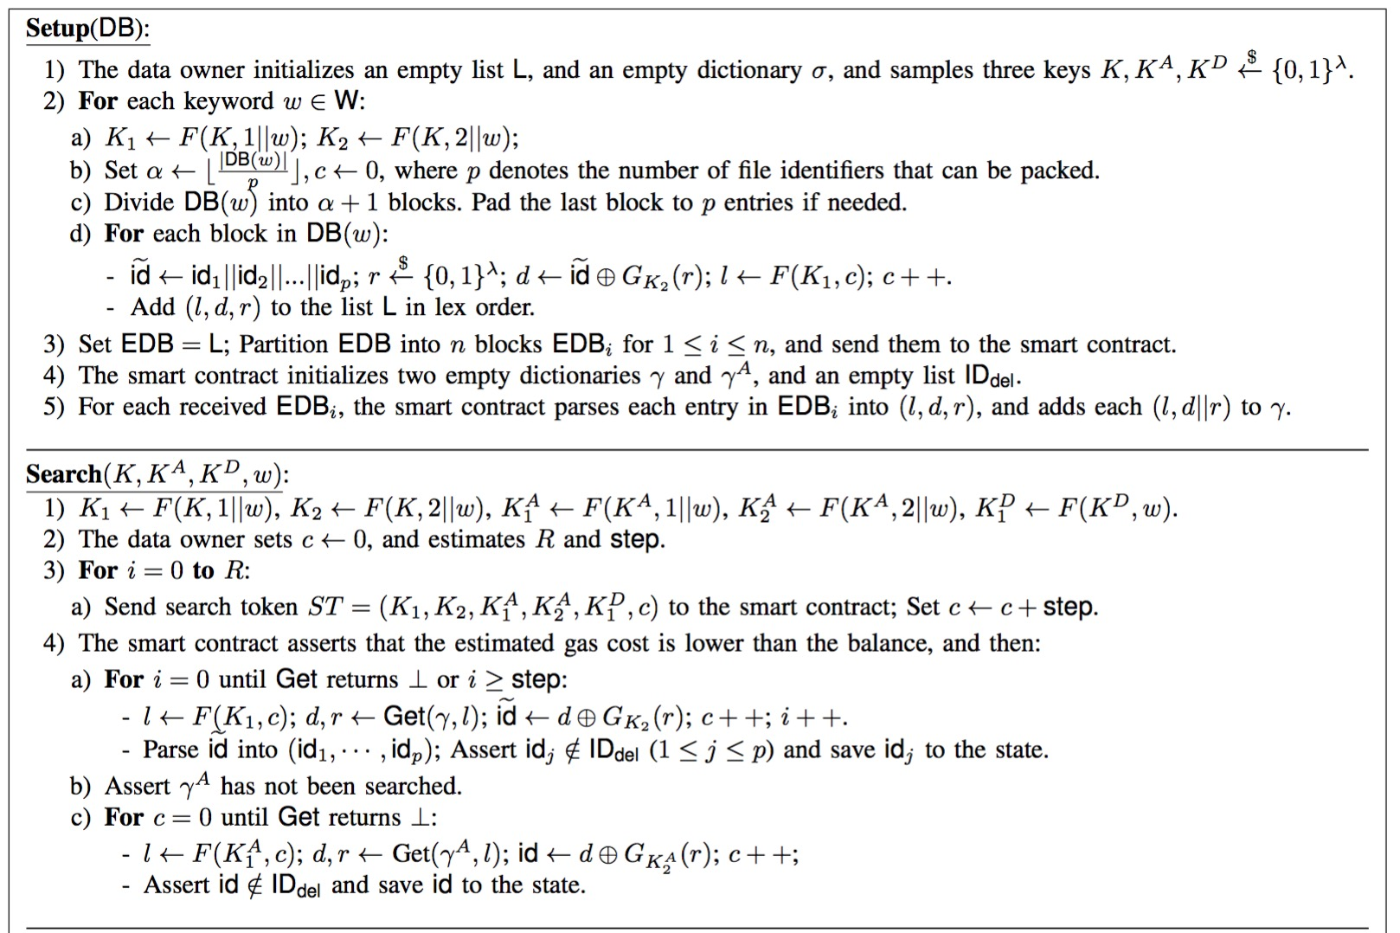

Fig. 3 Sample application

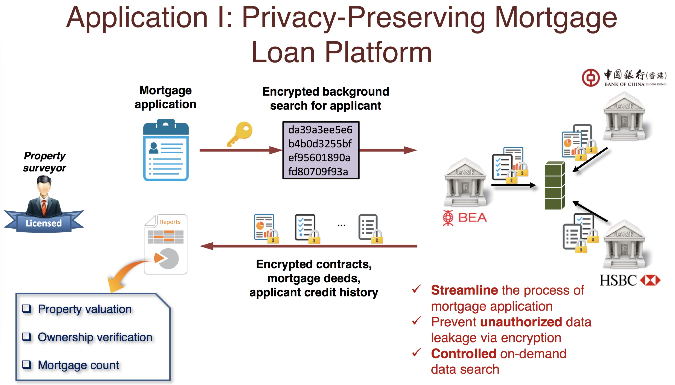

The architecture of encrypted search hardened by ***public blockchain*** is illustrated in Fig. 4, which contains three main modules:

* **Client module:** porting plaintext datasets to encrypted search module and generating secure queries;
* **Encrypted search module:** providing encrypted data storage and privacy-assured keyword search service;
* **Blockchain module:** anchoring integrity metadata and enabling fair judgment in case of disputes;

Fig. 4 System architecture

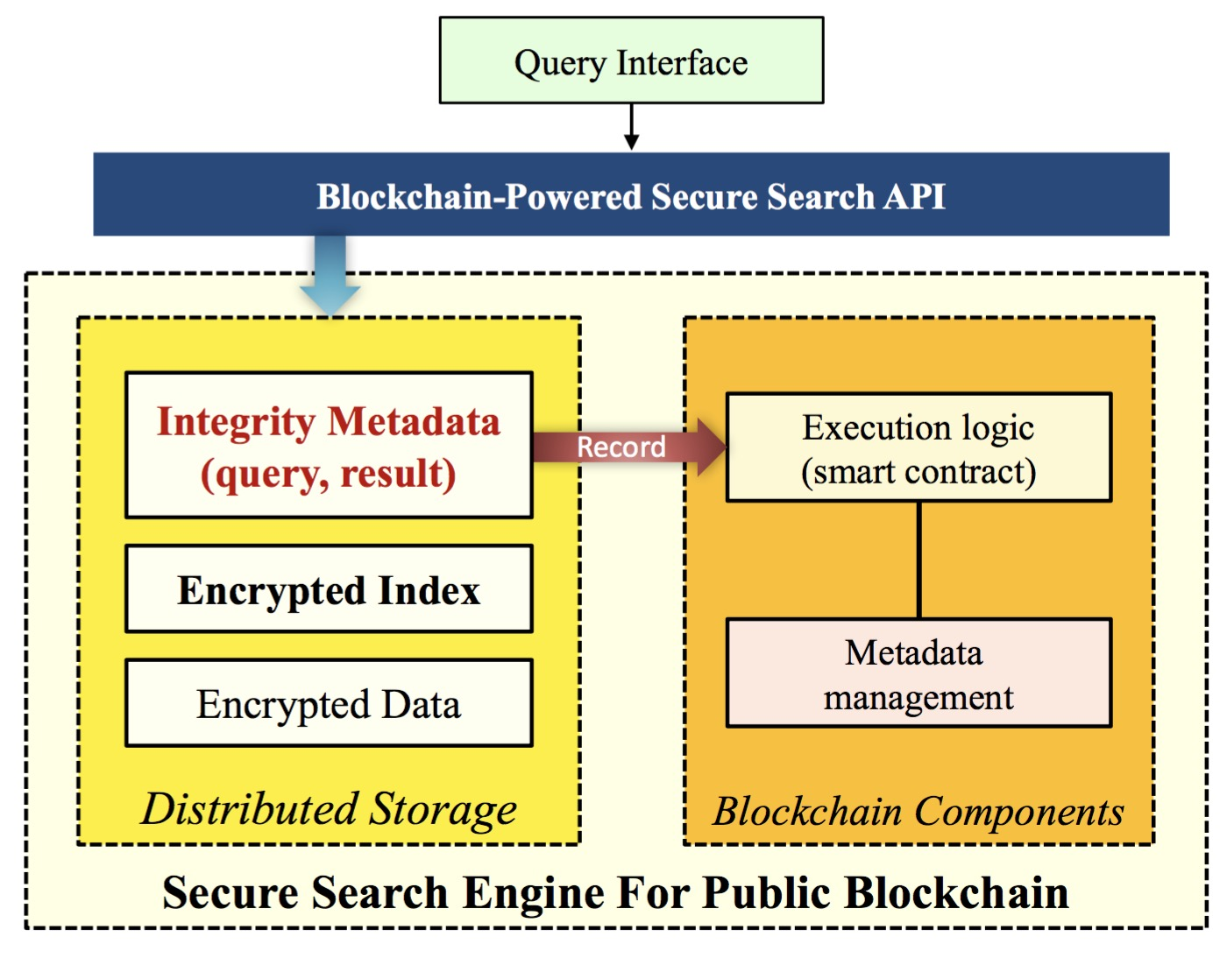

Fig. 5 Core protocols

(for more clarifications, please refer to our documents)

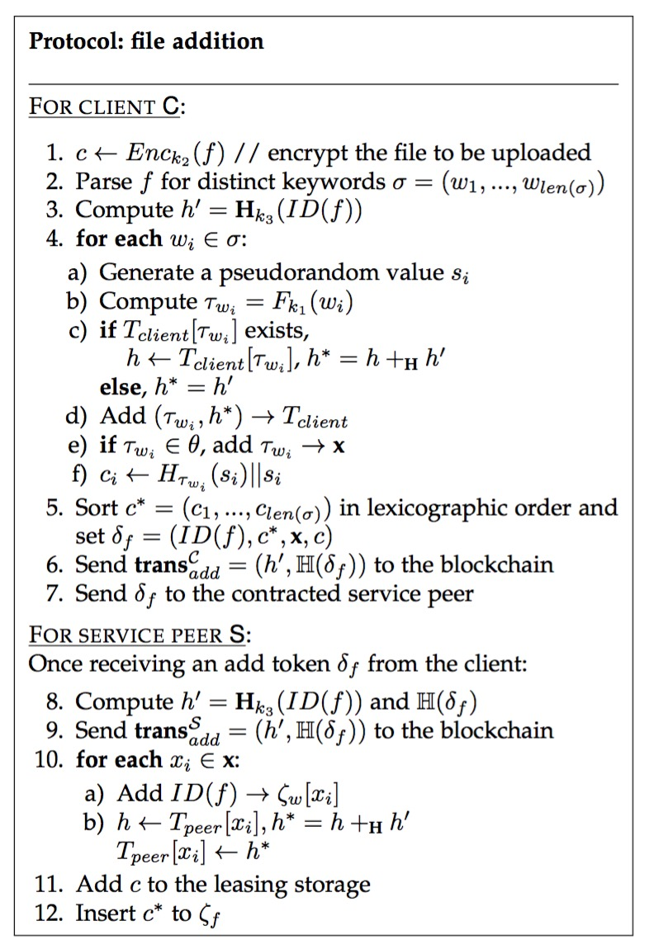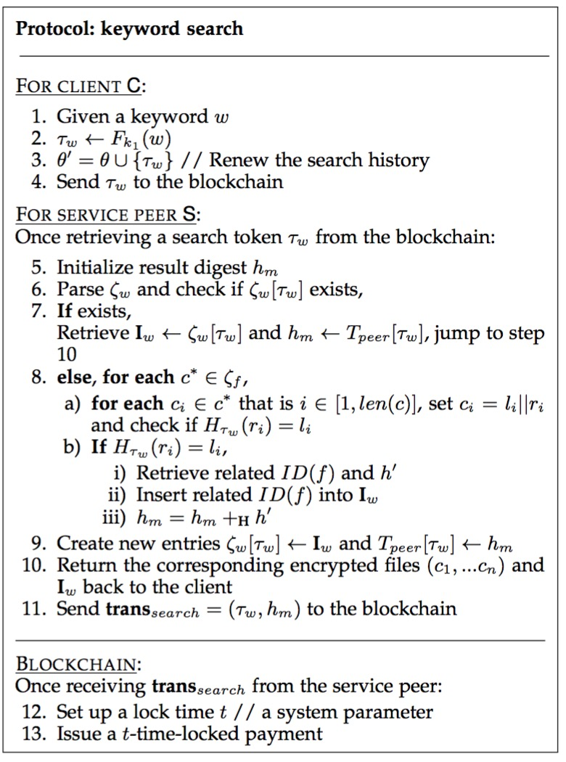

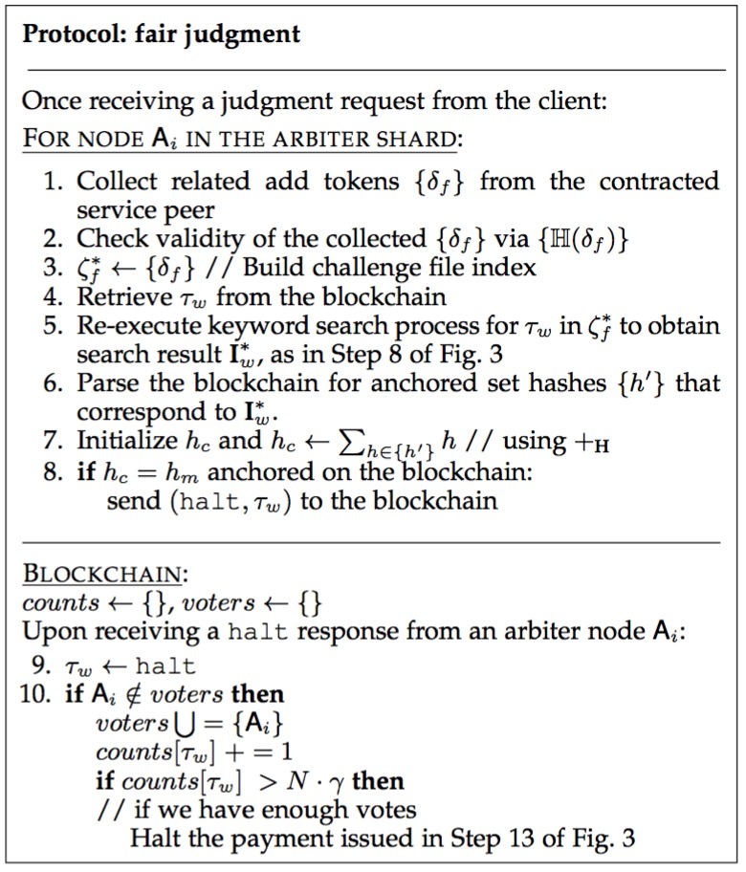

Fig. 6 Sample application

